EMPLOYEE FEEDBACK REPORT
- How do you rate the effectiveness of the students in developing innovative thinking?
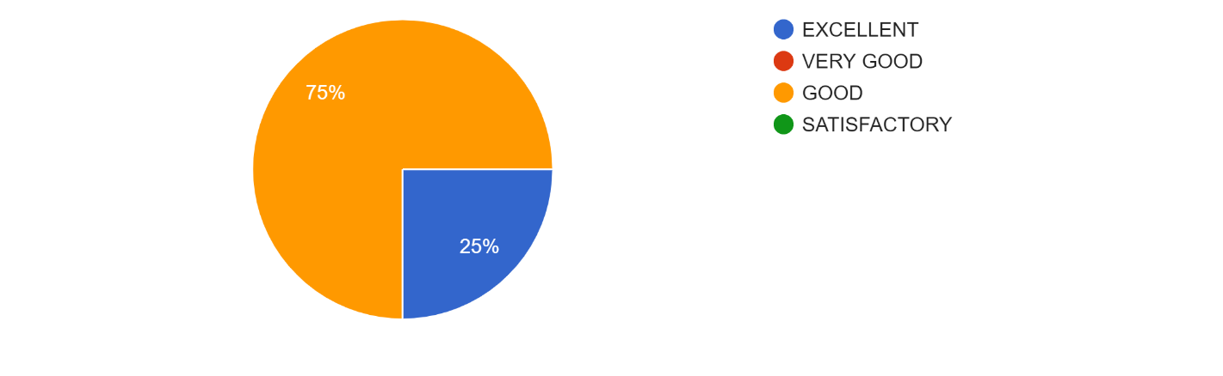
- How do you rate the curriculum in helping the students becoming entrepreneurs?
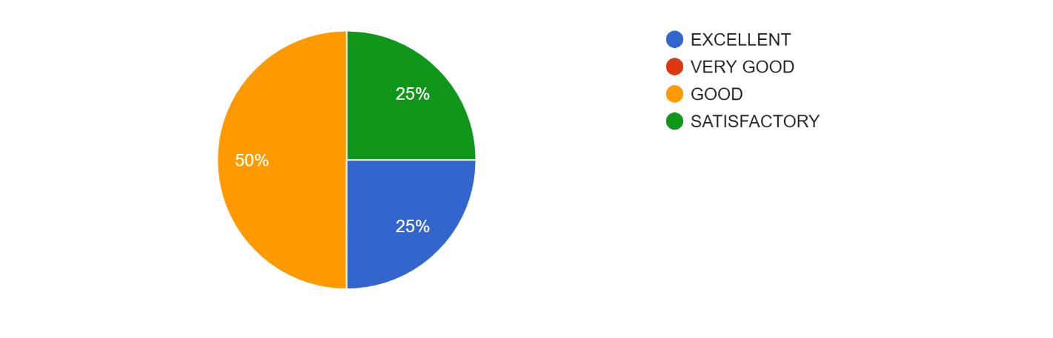
- . How do you rate the syllabus in relevance to keeping students employable without prior training?
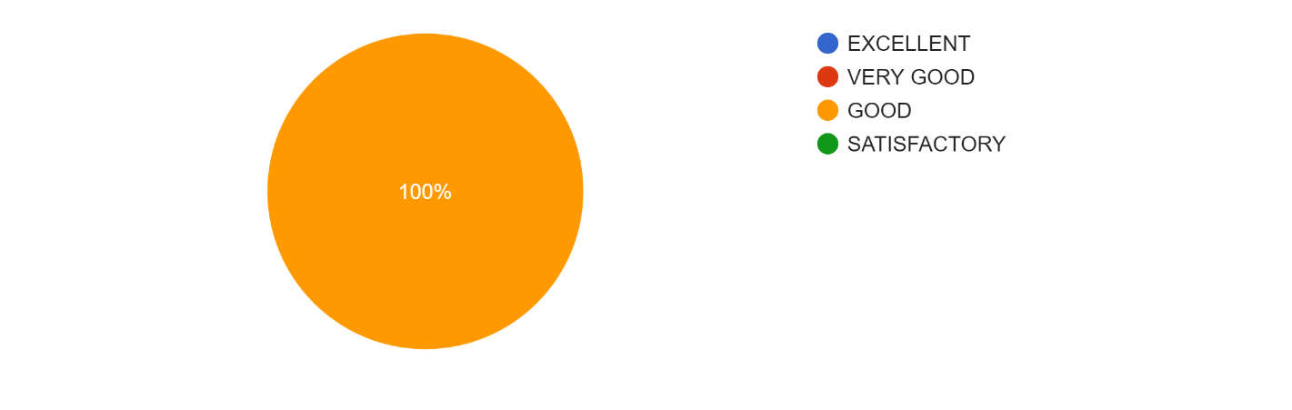

- How do you rate the curriculum in connection with industrial standards?
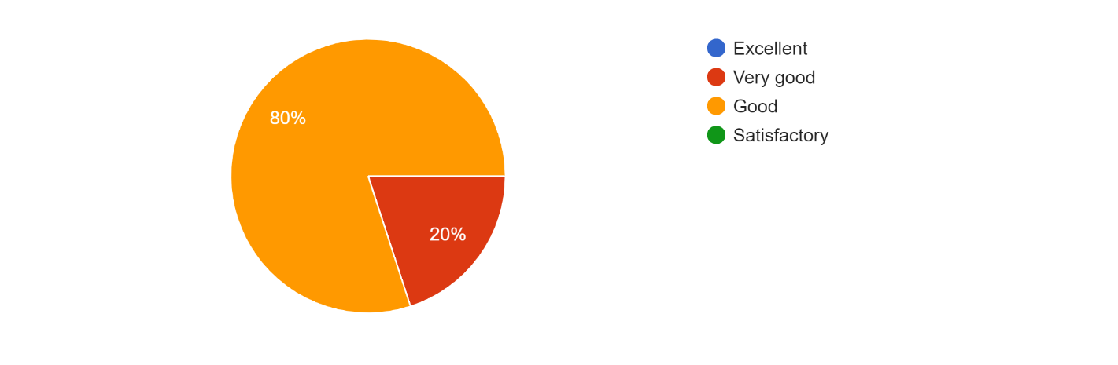
- How do you rate the syllabus enhance the quality of students in terms of technical and communication skill
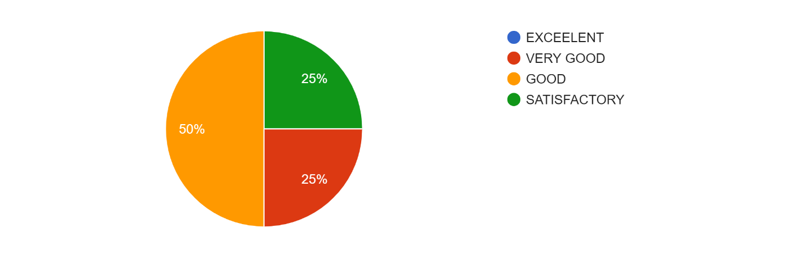
- Is the curriculum compatible with the real world problems?
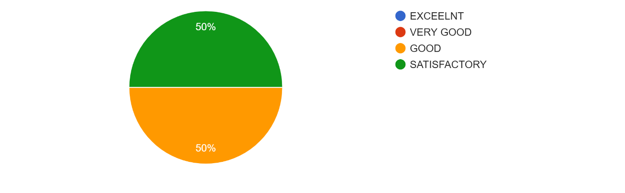
- How do you rate the effectiveness of the students in developing innovative thinking?
